Instagram Marketing Strategy
Name
Institution

Being successful within the market requires a focus on essential elements that define the ability to have better engagement within the market. Different company's employee marketing strategies that emphasis on uniqueness and the ability to have more significant influence within the market. Instagram has focused on providing a differentiated service within social media which has ensured that it becomes one of the most interactive social networking platforms. The development of Instagram concentrates on simplicity and inspiring creativity through solving problems based on more attractive product design such as the graphical user interface and the ease to videos and picture stories. Thus, based on these elements, Instagram has become a key player in visual storytelling across different players including celebrities, brands and other users who focus on sharing content through Instagram. Integration of essential elements within organizational development helps in creating a more attractive business environment where it is possible to meet the needs of consumers in the market as well as developing a stronger competitive advantage within the highly competitive industry that is based on creativity.
Marketing strategy
The marketing strategy that is adopted by an organization is based on the integration of key concepts that define positive change. An organization decides based on the underlying organizational goals and market trends. Instagram has focused on stories marketing strategy. Within a business environment, there are different measures that companies tend to employ to diversify its presence and improve overall commitment. The stories strategy that Instagram implement within its platform was the similar idea that Snapchat was utilizing although there was a need to ensure that Instagram integrates better concepts that define positive change based on its engagement within the market as highlighted in figure 1 (Chacon, 2018).

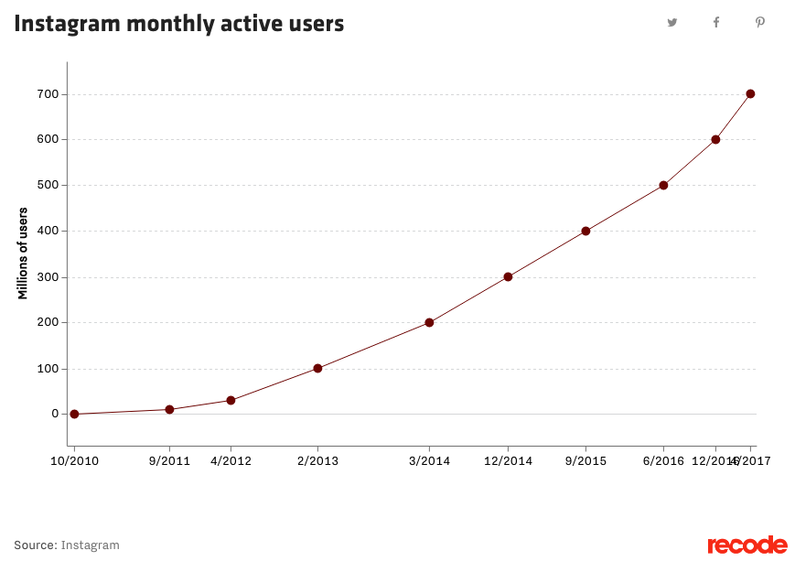
Figure 1 Source (Instagram).
The content sharing within the platform is based on a certain level of quality which creates a difficult understanding of essential elements that define positive development. However, although the company strategy has been successful, many people still feel that the strategy does not define Instagram because it was not their original idea. Instagram was initially marketed as being a platform for celebrities rather than for the general public.
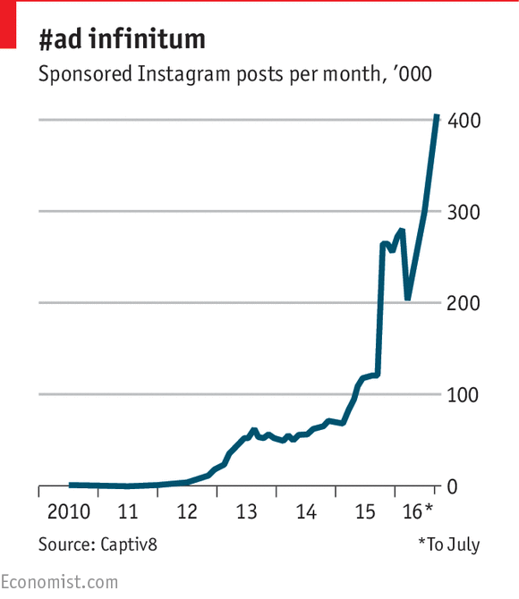
Figure 2; Celebrity endorsement (source, Economist)
As shown in figure 2, celebrities are paid to endorse products and services on Instagram which influences the lives of other users who want to be like them. Therefore, the major problem facing Instagram is the pressure of sharing only amazing photos because that is how it is being perceived in the market (Miles, 2014).
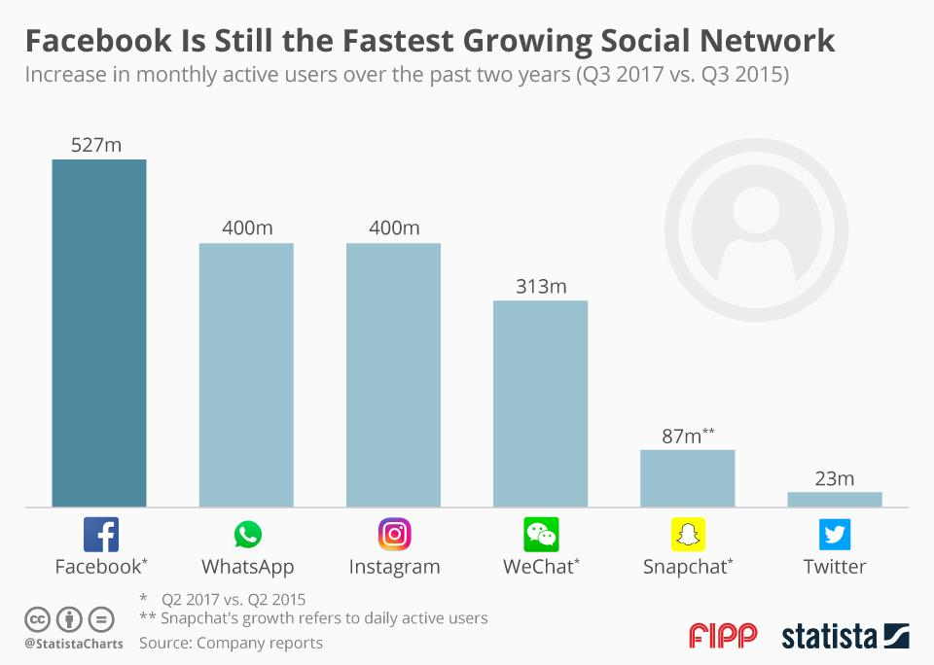
Figure 3; Source (Statista, 2016).
Launching stories have been the major success for Instagram which has helped build a strong global brand which has also integrated diverse concepts where businesses and brands advertise their products on their pages. It is considered one of the best decisions to have come out of Facebook as a company. Even though stories this not save Instagram, it has been instrumental to the growth of the company over the years as many users have come to understand how Instagram works. Instagram stories have changed individual interaction within social media which explain approximately 400 million users daily (Figure 3). The manner in which people consume and share things online has been significantly transformed based on the new development of the Instagram approach to information sharing online (Stelzner, 2018).
Competition
Competition has been very stiff especially considering that different platforms have focused on integrating stories on their platform which is essential in building a high level of interaction among users. The direct competition of the company has been Snapchat. However, despite Snapchat having been the creative brains behind the stories marketing strategy, it has been unable to integrate better measures which focus on creating a profoundly transformed environment where it is easier to implement better strategies. Instagram has been on the rise since its launch considering that the company understood the main concepts which define positive business development based on the preferences and the needs of users as highlighted in figure 4. The major concepts that define positive development include easy user interaction and the ability to share content selectively with specific users. (Miles, 2014).
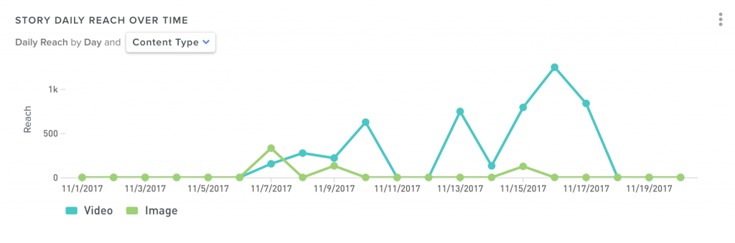
Figure 4; Source (Stelzner, 2018).
The adoption of stories strategy by Instagram led to the significantly slow growth of Snapchat which has been on downward spiral creating a very difficult operational environment. Instagram has been very competitive especially considering that most of its customers are crossing over from Snapchat which has failed to improve its performance since the launch of Instagram stories as highlighted in figure 5.
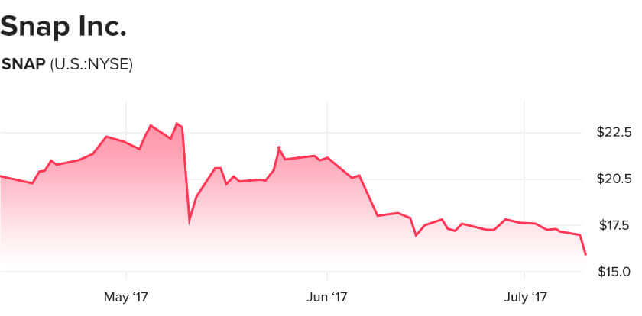
Figure 5; Source (US.; NYSE).
Stories are expected to be highly interactive and allow users to share information which is vital to maintaining a high level of commitment to Instagram as highlighted in figure 6. Most of the content that is shared on Instagram is shot casually which integrates essential concepts such as curiosity to understand some of the crucial parts of the lives of most prominent individuals. The ability to interact with celebrities and brands help create a close interaction between individuals within the platform (Wagner, 2018).
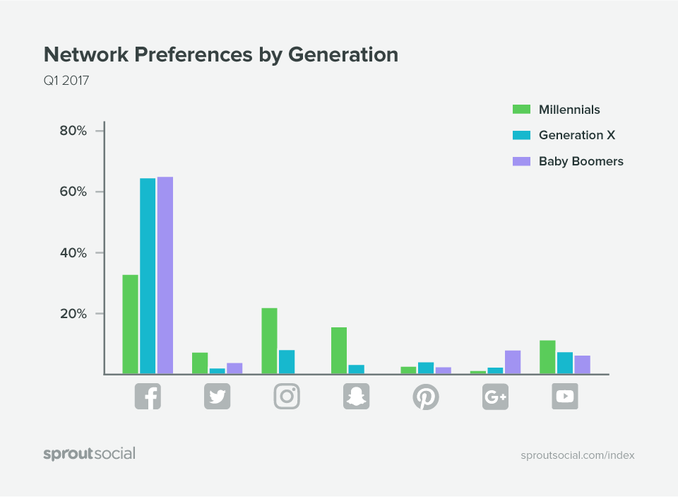
Figure 6 ; Source (Sprout social).
The changing technology requires integration of essential concepts that define positive performance within the industry and achieve a greater market share. Therefore, to improve customer experience, Instagram has added necessary functionalities to improve the user experience. The additional features include texts, captions, stickers, GIFs and videos which are uniquely defined as compared to snapchat. These measures have created a highly effective emphasis on the need to develop a diversified environment where users can have fun. Instagram is a social platform thus it is vital to ensure that users socialize and connect seamlessly based on their needs and personalities as shown in figure 6. The feeling of freshness is essential and provide a strong emphasis on better concepts that define the positive integration of better developmental ideas (Wagner, 2018).

Opportunities
Instagram has a higher chance where it is possible for the company to integrate diverse concepts that define is engagement within the social media. The increasing level of creativity regarding the additional functionalities that the company has been putting in place create a better understanding on better concepts that need to be evaluated to improve the company engagement within the industry (Stelzner, 2018). Instagram has employed some of the most creative and innovative employees who have a strong understanding of the direction of the industry thus ensure that the company implements these concepts that promote positive development as shown in figure 7. The company is visionary based on the strategies that it has been putting in place which define a greater emphasis better concepts that define positive development. The technology environment is diverse hence there are infinite opportunities that the company can adapt to improve its engagement within the industry.
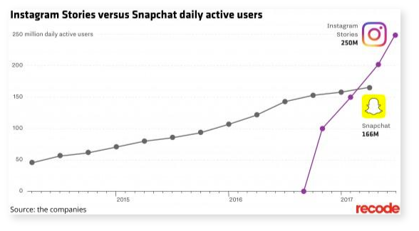
Figure 7; Source (the companies).
Threats
Despite the significant engagement of the company within the social media industry and the success of its stories marketing strategies, the company is still faced with multiple threats which aim at derailing the company progress. The inability to integrate better terms and conditions which focus on user privacy has been the leading threat which is likely to create a very difficult level of operational because users are unsure of whether the company is sharing their personal information with third parties or not. The company has been unable to penetrate in many parts of the world considering its operational policies and the content that is shared. The company is unable to fully control the content that their users upload to their accounts. Thus it is difficult to keep track of the story shared and evaluation on whether it is fit to share or not (Miles, 2014).

References
Chacon, B. (2018). How to Use Instagram Stories for Marketing (And Why You Should). Retrieved from https://www.shopify.com/blog/how-to-use-instagram-stories
Chen, H. (2018). College-Aged Young Consumers' Perceptions of Social Media Marketing: The Story of Instagram. Journal of Current Issues & Research in Advertising, 39(1), 22-36.
Miles, J. (2014). Instagram power: Build your brand and reach more customers with the power of pictures. New York, NY: McGraw-Hill Education.
Stelzner, M. (2018, August 02). Instagram Stories Strategy: How to Make Stories That Benefit Your Business. Retrieved from https://www.socialmediaexaminer.com/instagram-stories-strategy-how-to-make-stories-benefit-your-business-tyler-j-mccall/
Wagner, K. (2018, August 08). 'Stories' was Instagram's smartest move yet. Retrieved from https://www.recode.net/2018/8/8/17641256/instagram-stories-kevin-systrom-facebook-snapchat

